Irish National Championships
&
ITA Irish Cup 2025

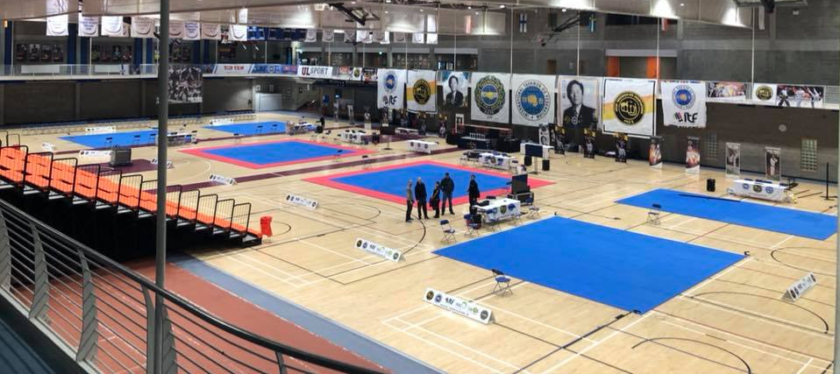

8th – 9th November 2025
University of Limerick Arena

Date: National Championships
8th November 2025 – 15 & Under, 15-17, Senior Black belts
ITA Irish Cup
8th November 2025 – 14+ Colour Belts, Veteran Black Belts
9th November 2025 – Aged 13 and Under Colour Belts

Location: University of Limerick Arena

Registration: From 8:30am on both days of competition

Weigh in: Friday (TBC Please check ITA Facebook for Updates) Saturday 8:30am – 10:00am, Sunday 8:30am - 9:30am
Height Check: Sunday During Pattern competition
Umpire Meeting: 9:30am on both days
Start of competition: 10am on both days
Entry Fee: €35 per competitor
Important Dates:
15th September 2025: Online Registration Opens
31st October 2025: 23:59 Registration Closes
6th November 2025: Schedule Published Online
** Withdrawal of competitor before 27th October is possible without a fee **
competitors withdrawn after this date subject to full entry fee
No changes/additional entries in pattern, sparring, special technique or power categories on the day of the event and any competitor entered in the wrong category will be removed
Age Categories
National Championships
Saturday: 15 & Under Black Belt, 15-17 Black Belt, Senior Black Belt (18+)

ITA Irish Cup
Saturday: 14-17 Colour Belt, Senior Colour Belt (18+), Veteran (35+)
Sunday: Under 10, Colour Belt (11-13)
Categories
Patterns
Colour Belts: Optional Pattern
Black belts: Preliminary Rounds: 1 x designated patterns (Chon-Ji - Current Grade)
Semi Final & Final: 2 x designated patterns
This is for Cadet and Senior patterns only, 15 & Under and Veteran Black Belt categories will be from Chon-Ji – 1st Dan Patterns
Sparring
Saturday: Weight Categories
Sunday: Height Categories all Under 10, 11-13 Yellow/Green
Height/Weight for 11-13Yrs Blue/Red Belts
*Note: For 11-13 years Blue/Red belts, categories are initially divided by height but may be adjusted or modified at the discretion of the tournament committee to take competitor weights into account, please also include weights on entries for these competitors
The organisers reserve the right to further divide categories if there is a large difference in weight/height across the category.
Match Times
Irish Cup
Under 10: 1 round, 1.5 minutes
Colour belts (11 yrs+) & Veterans (35+): 1 round, 2 minutes
National Championships:
Black belts (3 competitors Pools): 2 rounds, 1.5 minutes
4+ Competitors Black belts:

Main Draw: 2 rounds, 1.5 minutes
Finals: 2 rounds, 2 minutes Requalifying matches for 3rd place: 1 round, 2 minutes
Special Technique Blue/Red Belt 11 Yrs + M/F: Front Kick & Side Kick
Turning kick may be used as a playoff technique
Black Belt M/F: Front Kick, 360 Mid Air Kick, Reverse Turning Kick
In the event of a playoff, any of the 5 techniques may be selected
Power Black Belt M/F: Knifehand Strike, Side Kick, Turning Kick
In the event of a playoff, any of the 5 techniques may be selected
Special Technique/Power heights/number of boards on last page of invite.
Umpires
Saturday: 1 – 7 competitors = 1 umpire, 8 – 14 competitors = 2 umpires etc.
Sunday: 1 – 10 competitors = 1 umpire, 11 – 20 competitors = 2 umpires etc.
We need as many senior umpires as possible to ensure a high level of refereeing on all rings.

All umpires will receive free lunch and snacks on the day of the competition.
Umpires must wear: Navy pants, navy jacket, white shirt, tie, white shoes.
International teams may be excused the requirement to provide umpires
Coaches
There will be no coaching allowed during patterns.
Clubs must meet the umpire to competitor ratio on each day they to receive coaching passes
1-15 competitors = 1 coach, 2-30 competitors = 2 coaches etc. Maximum of 1 coach per ring
Saturday coaches may be cadets (14-17) or seniors, who can coach at ringside.
Sunday coaches must be cadets (14-17) blue belt upwards. No senior coaches are allowed at ringside.
In the interest of fairness on Sunday, if one competitor does not have a coach for a match then the other competitor will not be allowed a coach for that match.

Safety Equipment: Equipment must be of an ITF approved type.
All competitors must wear:
- Head Guard
- Gloves (open palm, enclosed fingers)
- Foot pads
- Shin Guards
- Gum Shield (Clear)
- Groin Guard (compulsory for all male competitors)
Any strapping, supports must be accompanied by a medical note, however the T&U committee will make the final decision to allow the competitor to compete or not.
Contact and skill development
We place an emphasis on skill development over heavy contact in our events. Heavy contact will not be tolerated.
ITF Sparring is light contact, with the technique controlled on the target. Points will be awarded as follows:
- One point for hand techniques to body or head
- Two points for foot technique to the body
- Three points for foot technique to the head.

Awards
Colour Belts: 1st, 2nd and joint 3rd Place
Black Belts: 1st, 2nd and 3rd Place
Special Technique/Power: 1st, 2nd and 3rd Place (2nd and 3rd in case of tie breaks)
Under 10 competitors up to green tag who are not placed will receive a commemorative medal.
Overall competitor awards for the most outstanding performance at cadet and senior black belt level.
Weight / Height Control
Competitors must wear a t-shirt and dobok pants. A 1kg tolerance is permitted.
On Sunday height control for juniors will take place during the patterns divisions. As each competitor is eliminated they will have their height checked. Any competitor not taking part in patterns must have their height checked during this time as well.
When registering please ensure your competitors are checked in the club and not at home. Instructors must take full responsibility for any incorrect heights or weights and must sign each entry form.

Insurance
All competitors must have adequate insurance for all eventualities.
Conduct:
All participants in the event, competitors, coaches, the public, umpires etc. should conduct themselves according to the tenets of Taekwon-Do at all times.
Competition Divisions/Categories
Divisions / categories must consist of two or more competitors – if there is only one competitor he/she will compete in a higher or lower category as deemed appropriate. This will be indicated on the competitor sticker as ReCat Up or ReCat Down as appropriate
For full list of categories please see the event page on the sportdata.org web page
Competition area
Only competitors for current division, officials, coaches with passes, tournament committee / organisers and VIPs allowed on competition floor.
Updates and other information will be published on ITA website and Facebook page and emailed to registered clubs as necessary
ITA Tournament and Umpire Committee
Tournament Director Umpire Chairperson
Master Mark Buckley VII Dan Mr Carl Smullen VI Dan
Tournament Coordinator Tournament Administrator
Master Stephen Ryan VII Dan Mr Stephen Smullen VI Dan

Contact
Email: entries@taekwondo.ie
Techniques and Heights for Special Technique
Blue/Red Belts  11-13 Years | Female 11-13 yrs -155cm | Female 11-13 yrs +155cm | Male 11-13 yrs -155cm | Male 11-13 yrs +155cm
Flying high front kick (Scissors Motion) | 180 | 190 | 190 | 200
Flying high side kick | 90 | 100 | 100 | 110

Blue/Red Belts  14-17/Senior | Female 14-17 years | Female Senior | Male Senior | Male 14-17 years
Flying high front kick (Scissors Motion) | 200 | 200 | 230 | 220
Flying high side kick | 110 | 110 | 120 | 120

Black Belts | 15 & Under Male | 15 & Under Female | 15-17 Yrs Male | 15-17 Yrs Female | Senior Male | Senior Female
Flying high front kick (Scissors Motion) | 220cm | 200cm | 240cm | 210cm | 250cm | 220cm
Flying turning kick  (Scissors Motion) | 190cm | 170cm | 210cm | 180cm | 220cm | 190cm
Flying reverse turning kick | 170cm | 170cm | 190cm | 170cm | 200cm | 180cm
360 mid air kick | 170cm | 170cm | 190cm | 170cm | 200cm | 170cm
Flying high side kick | 120cm | 110cm | 130cm | 110cm | 140cm | 120cm
Note: Measurements for height are made from the surface of the floor or mat, to the bottom (lowest) edge of the board, or tape in the case of the high side kick.
Power Breaking
Technique | Junior Female | Junior Male | Senior Female | Senior Male
Forefist front punch (M) Front Elbow Strike (F) | 1 | 1 | 1 | 2
Knifehand strike | 1 | 2 | 1 | 2
Side piercing kick | 2 | 3 | 2 | 3
Turning kick | 1 | 2 | 2 | 2
Reverse turning kick | 1 | 1 | 2 | 2
Black Belts will compete with the 3 highlighted techniques above

